Benefits of Compression Rash Guards for Brazilian Jiu-Jitsu

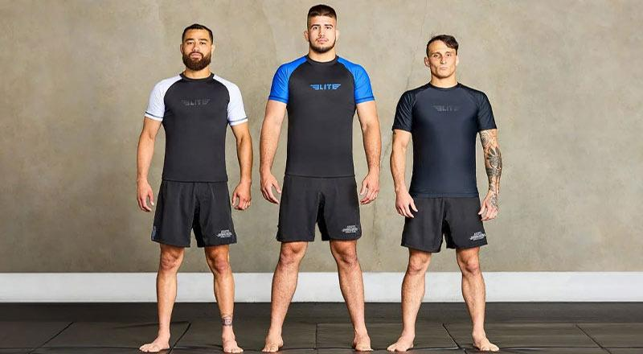

Table of Contents
1. What Is a Compression No-Gi Rash Guard?
2. The Key Benefits of Compression Rash Guards for Brazilian Jiu-Jitsu
2.1 Skin Protection from Mat Burns and Abrasions
2.2 Improved Blood Flow and Faster Recovery
2.3 Moisture-Wicking to Stay Dry and Odor-Free
2.4 Full Range of Motion with 4-Way Stretch and Flat-Lock Seams
2.5 Anti-Slip Fit That Stays Locked in Place
2.6 Muscle Support and Pre-Training Warmth
2.7 IBJJF Approved for Tournament and Competition Use
3. Choosing the Right Compression Rash Guard
4. Why Elite Sports Is a Top Choice for Brazilian Jiu-Jitsu Athletes
5. Final Thoughts

Every time a grappler steps onto the mat, what gets worn during training matters far more than most beginners expect. The right top can protect the skin, support the muscles, and keep an athlete cool and dry through the hardest sessions of the week. For Brazilian Jiu-Jitsu athletes, a compression no-gi rash guard is not just a piece of training gear. It is a tool that directly affects how well and how long a fighter can train and compete.

Elite Sports, one of the best martial arts gear makers in the sport today, has built a trusted lineup of no-gi rash guards for Brazilian Jiu-Jitsu that serves grapplers from white belts through to competition-level athletes. Known for durable, professional-grade gear, the brand produces rash guards that hold up through years of hard training.

Continue reading this article to learn about every key benefit that a compression no-gi rash guard brings to the mat.

1. What Is a Compression No-Gi Rash Guard?

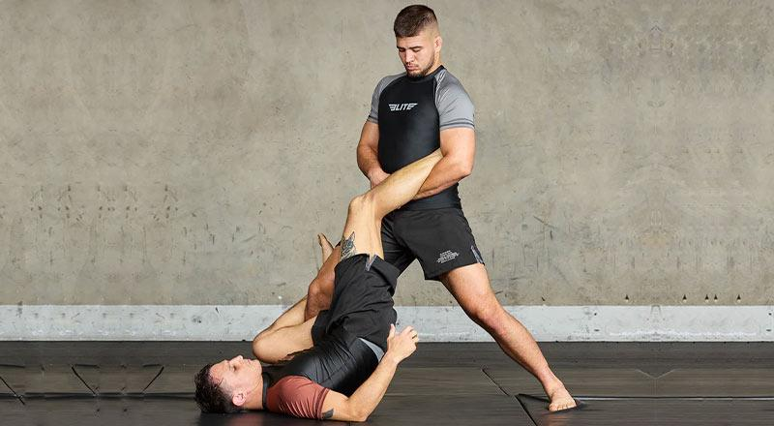

A compression no-gi rash guard is a tight-fitting top built from a blend of polyester and spandex. It wraps close to the body and applies an even, gentle pressure to the muscles. This is what sets it apart from a loose training shirt or a standard athletic top.

In Brazilian Jiu-Jitsu, the no-gi rash guard is worn during sessions where athletes train without the traditional kimono. The snug fit serves a clear purpose on the mat. It reduces friction between skin and the surface, keeps the body warm during warm-ups, and supports the muscles through hard sparring rounds. At its core, it is a functional gear designed with the needs of a combat sports athlete in mind.

2. The Key Benefits of Compression Rash Guards for Brazilian Jiu-Jitsu

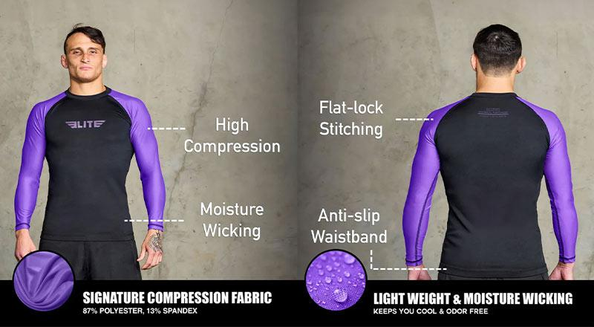

2.1 Skin Protection from Mat Burns and Abrasions

Mat burn is one of the most common problems grapplers deal with. Repeated rolling, scrambling, and driving across mat surfaces leaves raw, painful patches on the elbows, forearms, and knees. A long-sleeve no-gi rash guard acts as a direct barrier between the skin and the mat.

The Elite Long Sleeve No-Gi Men's Rash Guard is built with this in mind. The long sleeves completely cover the forearms, protecting the skin through every takedown, guard pass, and positional scramble. For athletes who train several times a week, this protection prevents a buildup of skin damage that would otherwise slow training.

2.2 Improved Blood Flow and Faster Recovery

The compression in a quality no-gi rash guard does more than just feel tight. Applied evenly across the muscle tissue, it can help improve blood flow during training rounds. Better circulation means muscles receive oxygen more efficiently, which can raise output during intense rolling sessions.

After the session ends, that same compression helps support faster muscle recovery. For Brazilian Jiu-Jitsu athletes who train multiple days per week, reducing the time until they feel fresh again is a meaningful edge. Elite Sports no-gi rash guards use an 87% polyester and 13% spandex blend that delivers firm, consistent compression without restricting movement. The fabric wraps the body evenly, supporting the muscles throughout the full session.

2.3 Moisture-Wicking to Stay Dry and Odor-Free

Hard rolling sessions produce a great deal of sweat. A top that holds moisture against the skin causes discomfort, chafing, and, over time, skin issues. A well-built compression no-gi rash guard uses moisture-wicking fabric to pull sweat away from the body and allow it to dry quickly on the outer surface.

Elite Sports no-gi rash guards are designed to absorb sweat and keep the skin dry throughout long training blocks. The same moisture-wicking construction also reduces bodily odor during extended sessions, making the rash guard practical not just for performance but for comfort. This benefit is especially useful for combat sports athletes who train twice a day or back-to-back sessions.

2.4 Full Range of Motion with 4-Way Stretch and Flat-Lock Seams

A compression top that limits movement defeats its own purpose on the mat. Brazilian Jiu-Jitsu requires deep hip movement, wide lateral drives, overhead reaching, and fast direction changes. The fabric and seam construction of a no-gi rash guard must keep up with all of it.

Elite no-gi rash guards feature a 4-way stretch fabric build combined with flat-lock stitching throughout. These flat-lock seams lie smooth against the skin and do not bunch or press into the body during ground work or guard drills. The result is a top that moves naturally with the body rather than pulling against it.

Key movement benefits include:
- 4-way stretch fabric that stretches fully in every direction, including overhead and wide lateral movements, without bunching or losing shape over time.
- Flat-lock stitching that keeps seams flat and smooth against the skin, preventing friction and discomfort during deep guard work or extended rolling rounds.
- Lightweight build that adds no drag or resistance during fast transitions, allowing athletes to move freely without the gear getting in the way.

2.5 Anti-Slip Fit That Stays Locked in Place

One often-overlooked feature in a good no-gi rash guard is the waistband. During active sparring, a top without a secure waist tends to ride up during standing exchanges or takedowns, exposing the midsection and causing distraction at critical moments. An anti-slip design at the waist solves this directly.

Elite Sports no-gi rash guards include an anti-slip waistband that keeps the garment firmly in place during both ground work and standing grappling. This design also prevents the rash guard from shifting and chafing the skin at the waist, a common source of irritation during long training sessions. The form-fitting cut ensures the rash guard stays put from the first warm-up drill to the final sparring round.

2.6 Muscle Support and Pre-Training Warmth

The steady pressure of a compression no-gi rash guard helps warm up the muscles faster at the start of a session. For early morning training or cold gym environments, this is a practical advantage. Muscles that are warm and loose from the start are less prone to pulls and minor strains during drilling and sparring.

During positional rounds and hard-drilling blocks, the support provided by the compression fabric also reduces fatigue in the arms, shoulders, and core. Over a long session, that sustained support adds up, allowing athletes to stay sharper for longer before fatigue takes hold.

2.7 IBJJF Approved for Tournament and Competition Use

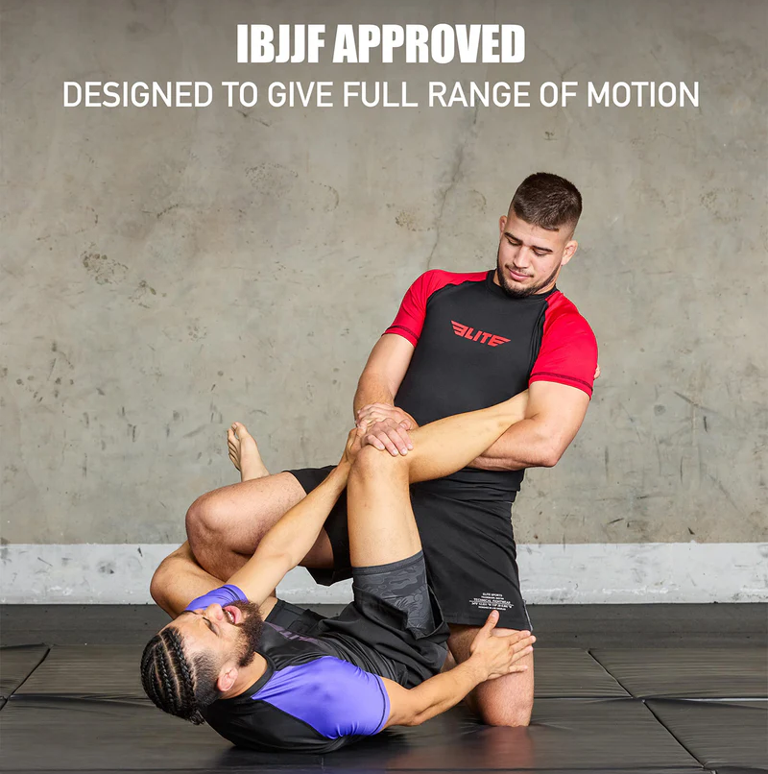

For grapplers who compete in Brazilian Jiu-Jitsu or other martial arts events, gear must meet official requirements to be approved for use on the competition mat. Elite Sports no-gi rash guards are IBJJF-approved, meaning they are cleared for use in official martial arts tournaments. Grapplers do not need separate gear for training and competition. The same rash guard worn in daily training can be used confidently on competition day.

3. Choosing the Right Compression Rash Guard

Not all no-gi rash guards are built the same way. Here is what to look for when choosing a compression rash guard built to last:
- Material quality: Look for a polyester-spandex blend that provides both compression and shape retention. A higher spandex content improves stretch, while polyester adds durability and moisture management.
- Seam construction: Flat-lock seams are a must for any grappler who trains regularly. Raised seams cause skin friction and break down faster under rolling stress.
- Sleeve length: Long-sleeve options provide full arm coverage and maximum skin protection from mat burns. Short-sleeve options trade some coverage for increased airflow.
- Fit and sizing: A compression rash guard should feel snug but never constricting. Check a detailed size chart before purchasing to get the right fit for both height and build.

4. Why Elite Sports Is a Top Choice for Brazilian Jiu-Jitsu Athletes

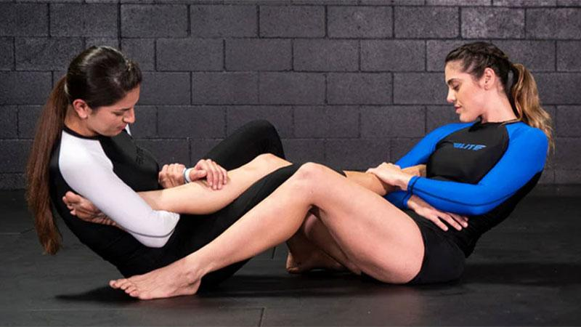

Elite Sports, widely recognized as the best no-gi rash guard brand for Brazilian Jiu-Jitsu and combat sports athletes, builds gear designed to withstand real-world training demands. The rash guards come in sizes from S to 3XL to fit a wide range of body types. Color options range from classic black and white through to gray, red, blue, brown, and purple, giving athletes a clean look on the mat.

The brand also covers the full training team. A dedicated women's range and a kids' range make Elite Sports a complete solution for all grapplers, regardless of age or gender. All Elite Sports products are backed by a 1-year warranty and ship within 2 days, with a 30-day return policy in place for hassle-free exchanges.

5. Final Thoughts

A compression no-gi rash guard delivers real, measurable benefits to every Brazilian Jiu-Jitsu athlete who puts it on. From mat burn protection and muscle support to moisture management, full range of motion, and competition-legal design, the advantages show up in every single training session. Elite Sports, widely regarded as the best martial arts gear producer for grapplers today, builds rash guards that meet all of these needs with durable, professional-grade construction.

For any martial arts athlete who is serious about training hard and staying healthy on the mat, a quality compression no-gi rash guard is not an optional add-on. It is part of the standard kit.

